Executive Summary
LAX Passenger Traffic Forecasting Analysis

Problem Statements:

Los Angeles International Airport (LAX) needs reliable passenger traffic forecasting to help future infrastructure, improve terminal operations, and reduce congestion. This analysis uses historical passenger data from 2007-2023 to forecast future traffic patterns to advise airport management.

Report Data & Method

The Dataset was obtained through the official City of Los Angeles website, with the dataset consisting of monthly passenger traffic records from 2007 to 2023 across all LAX terminals. The data include 6,059 observations segmented by terminal, arriva/departure status, and domestic/international classification. After preprocessing to consolidate terminal categories and remove NaN records, a SARIMA model was selected due to the data’s strong seasonal patterns and will be utilized to forecast future traffic totals. Model validation includes residual diagnostic, autocorrelation test, and performance metric evaluations to test model accuracy.

Key Findings:

Terminal Traffic Distribution: The Tom Brady International Terminal (TBIT) had the highest passenger volume at ~16m total passenger, representing the majority of total volume. Terminal 4 followed with around ~12m passengers, while other terminals on average ranged between ~4-9m in annual volume. This uneven distribution creates operational inefficiencies and congestion bottlenecks primarily concentrated at TBIT.

Traffic Volume: Domestic flights made up the majority of LAX traffic and demonstrated stronger post-pandemic recovery compared with international travel. While domestic traffic rebounded to near pre-2020 levels by 2023, international traffic recovery has been slower. This suggests difficulties in potential revenue collection and marketing concerns.

Seasonal Patterns: Traffic showcased predictable monthly fluctuation with peak volumes occurring during summer months (July-August) and substantial dips in winters (January-March). These patterns are consistent throughout the years, with predictable seasonal ups-and-downs.

COVID-19 Impact: The 2020 pandemic caused a dramatic traffic collapse from 8+ million to near zero monthly passengers. Recovery began in 2022, following historical seasonal patterns but reduced from its peak in 2019. This reflects a shift in travel behavior, so forecasting model should consider the disruption and new baseline when predicting future trends

Forecasting Outlook and Performance

The SARIMA (1,0,1)x(2,0,0m12) model successfully captured both trend and seasonal components in the data, achieving strong performance metrics of R^2 of 0.80, MAPE of 15%, and RMSE of 713,000 passengers. All model coefficients were statistically significant (p <0,05), and statistical summaries exhibit no significant strange behavior or figures, showcasing the model’s reliability. Based on the reliability of the modeling we can move onto forecasting results.

The 12-month forecast of (November 2023 - October 2024) predicts relatively stable traffic around 6-6.5 million passengers monthly, following typical seasonal patterns. The model anticipates lower volume during late 2024 into early 2025, consistent with historical winter trends. The predictions were conservative, suggesting that traffic will take a while to return to pre-2020 levels. However, traffic is maintaining steady recovery and is expected to gradually approach pre-pandemic level over the longer term with assumption to current trends.

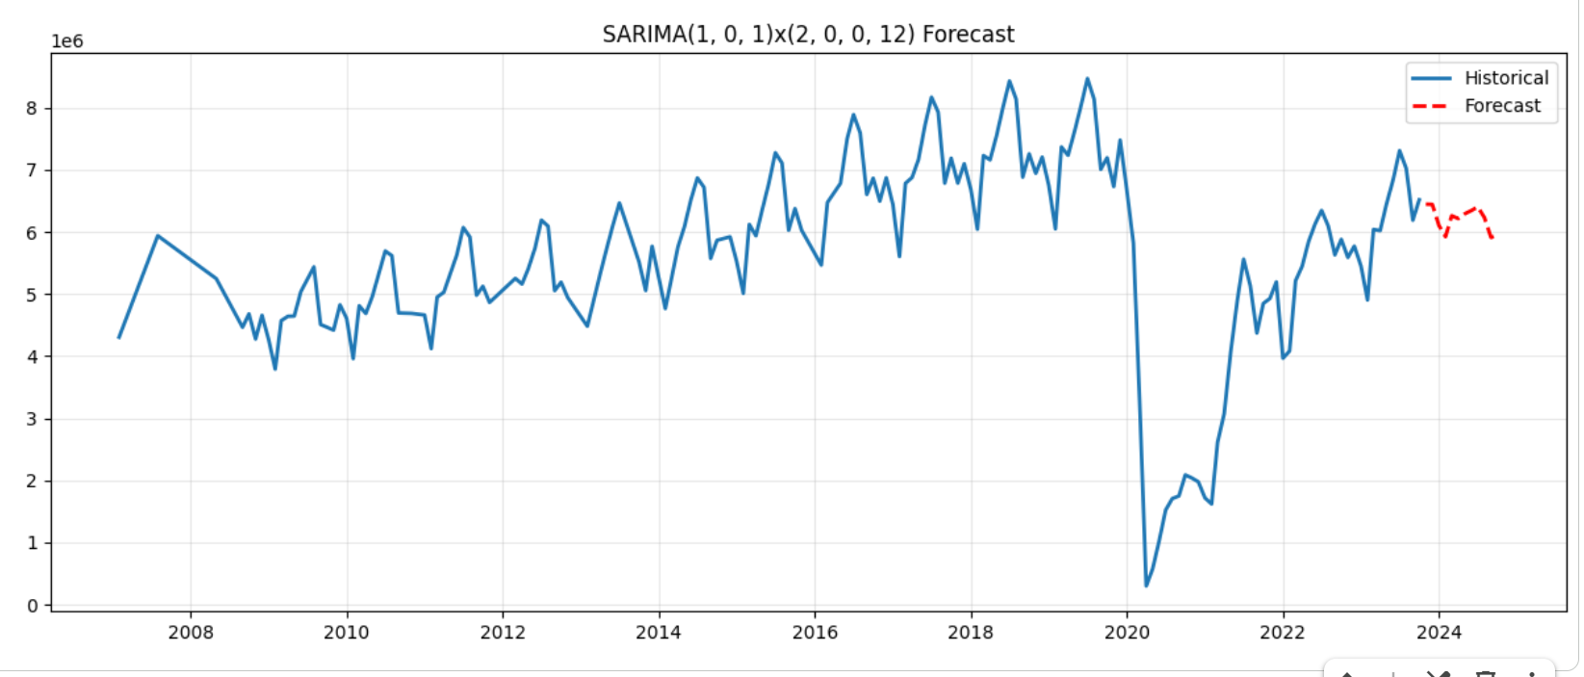

Strategic Recommendations

- Infrastructure investment: Prioritized capacity expansion at TBIT and Terminal 4 to address concentration risk. The 16 million vs 4 million passenger gap between TBIT and smaller terminals indicate potential bottlenecks that could worsen as traffic recovers and grows. Redistribute airline activity and expand capacity of TBIT as precaution.
- Seasonal staffing optimization: implement a resource allocation system that aligns with predictable summer peaks and winter lows. Add additional staff and services 2-3 months before peak periods to ensure operational efficiency.
- International Travel Recovery Support: Develop targeted strategies to accelerate international traffic recovery, which lags domestic travel. Consider partnering with international airlines and marketing campaigns to restore pre-prandemic international volumes
- Continuous Monitoring: Update forecast frequency as new data become available. The airport may exceed conservative forecast volume if recovery accelerates faster than historical patterns indicate due to unexpected outside trends or factors.

